1. A number is a Disarium number if the sum of the digits raised to the power of its respective position in the original number is equal to that number itself. Which of the following is the Disarium number ?

1. 89
2. 175
3. 123
4. 131

**ANSWER:** 89 & 175

x = int(input())

y = int(input())

z = int(input())

n = int(input()) #putting whole value to check

if x**1 + y**2 + z**3 == n:

  print("{} is a Disarium Number".format(n))

else:

  print("{} is not a Disarium Number".format(n))

2. Right now the time is 3:00 PM, if you will add 70 more hours, what would be the time then?

(skipped this question as we were told to do so).

3. A cricket player's statistics in the last 10 games are :__

Runs Scored : 23 , 56, 67, 9, 56*, 90, 41, 40, 104, 3

Balls Played : 45, 46, 90, 4, 44, 71, 70, 34, 81, 7

What is the average number of runs scored by the player in the last 10 games ?

What is the strike rate of a player in the last 10 games?

**AVERAGE RUNS SCORED:**

RUNS = (23 , 56, 67, 9, 56, 90, 41, 40, 104, 3)

avg_runs = sum(list(RUNS))/10

avg_runs

**Output: 48.9**

**STRIKE RATE:**

BALLS = (45, 46, 90, 4, 44, 71, 70, 34, 81, 7)

strike_rate = sum(list(RUNS))*100/sum(list(BALLS))

strike_rate

**Output: 99.39024390243902**

4. What is the value of the expression 100 / 25

1. 4
2. 4.0
3. Both
4. None

**ANSWER:** B. 4.0

5. What is the output of (1.1 + 2.2 == 3.3) ?

1. True
2. False

**ANSWER:** B. False

6. Create a variable x with the value 10. Increase the value of x tenfold using an augmented assignment operator?

**ANSWER:**

x = 10

x *= 10

x

Output: **100**

7. Which of the following are valid Python variable names ?

1. Var1.3
2. 4tower
3. Age
4. Upi_id
5. Upi66
6. Return

**ANSWER:** Age, Upi_id, Upi66, Return

8. What is the value of Temperature 101.5 degree Celsius into degree Fahrenheit ?

**ANSWER:**

Celsius = 101.5

Fahrenheit = Celsius * 9/5 + 32

Fahrenheit

Output: **214.7**

9.

What will be the value for x after executing the following code :-

x = 0

a = 0

b = -5

if a > 0:

if b < 0:

x = x + 5

elif a > 5:

x = x + 4

else:

x = x + 3

else:

x = x + 2

**ANSWER:** print(x), output: 2

10. What will be the value of the following code :-

print( not ( not a == 10 or not b == 10) )

**ANSWER:** False

11. What does the following code print out?

1

print("123" + "abc")

1. hello world
2. 123+abc
3. This is a syntax error because you cannot add strings
4. 123abc

**ANSWER:** D. 123abc

12. Which of these operators is not a comparison / logical operator?

1. =
2. ==
3. <
4. >=
5. !=

**ANSWER:** A. =

13. What is true about the following code segment:

if x == 5 :

print('Is 5')

print('Is Still 5')

print('Third 5')

1. Depending on the value of x, either all three of the print statements will execute or none of the statements will execute
2. The string 'Is 5' will always print out regardless of the value for x.
3. The string 'Is 5' will never print out regardless of the value for x.
4. Only two of the three print statements will print out if the value of x is less than zero.

**ANSWER:** A. Depending on the value of x, either all three of the print statements will execute or none of the statements will execute.

14. For the following code,

if x < 2 :

print('Below 2')

elif x >= 2 :

print('Two or more')

else :

print('Something else')

What value of 'x' will cause 'Something else' to print out?

1. This code will never print 'Something else' regardless of the value for 'x'
2. x = -2
3. x = -2.0
4. x = 2.0

**ANSWER:** A. This code will never print 'Something else' regardless of the value for 'x'

15. 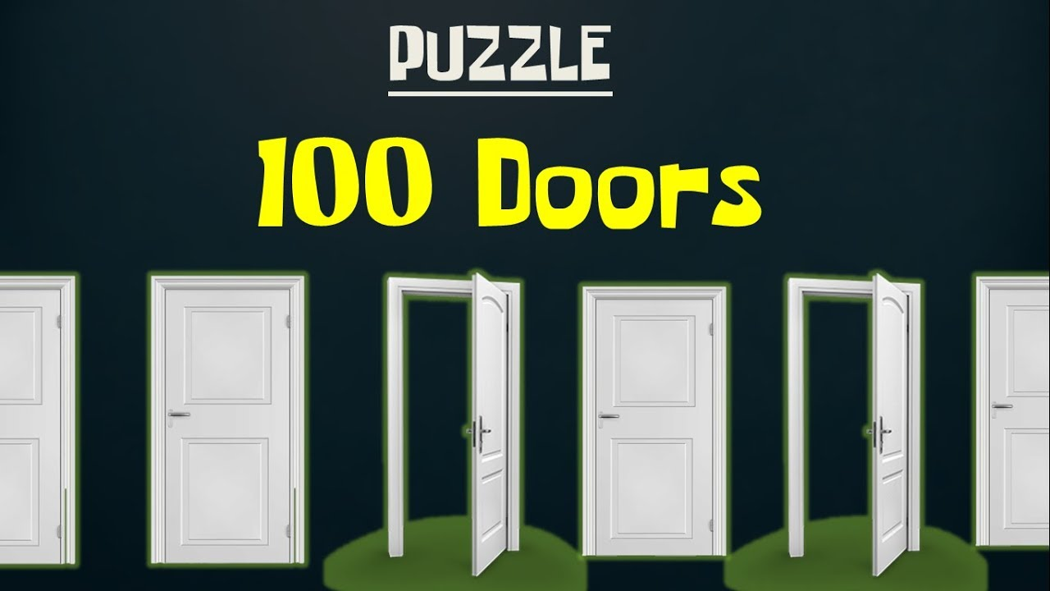

There are 100 doors in a row, all doors are initially closed. A person walks through all doors multiple times and toggles (if open then close, if close then open) them in the following way:

In the first walk, the person toggles every door

In the second walk, the person toggles every second door, i.e., 2nd, 4th, 6th, 8th, …

In the third walk, the person toggles every third door, i.e. 3rd, 6th, 9th, …

………

……….

In the 100th walk, the person toggles the 100th door.

What will be the position of door number 53 after this entire process ?

1. Open
2. Closed

**ANSWER:** B. Closed

doors = [False] * 101

for i in range(1, 101):

    for j in range(i, 101, i):

        doors[j] = not doors[j]

for i in range(1, 101):

    if doors[i] is True:

        print(i)